
Shamsi School
Shamsi Society Campus Boy’s Shift
Mid Term Exam 2025
Time: 3 hours
Student’s Name:__________________ Section: ___________ Date: _____________
Stud

Mid Term | Summer  Vacation | Written | Total  Check by: __________  Re-check by:________
Marks
Obtained
Max. Marks | 05 | 25 | 30

Objective: (Marks:25)
Q1) Choose the correct answers:
1) In numeral four hundred forty three thousand and six hundred and fifty seven.
a) 4,43,657 b) 443,657 c) 44,3657
2) 78,546 is more than 78,000 by:
a) 548 b) 584 c) 546
3) Angles greater than 90° but less than 180° are called:
a) Straight b) Acute c) Obtuse
4) What number is 100 less than 53,600?
a) 53,600 b) 53,400 c) 53,500
5) 145 × 30 is:
a) 4250 b) 4350 c) 4450
6) 168 ÷ 4 is:
a) 52 b) 48 c) 42
7) The Roman numeral for 19 is:
a) XIX b) IXX c) XXI
8) The successor of 99,999 is:
a) 1,00,000 b) 1,00,001 c) 99,999
9) The predecessor of the smallest 3-digit number is a ___ digit number.
a) 1 b) 2 c) 3
10) Angles equal to 90° are called:
a) Right b) Acute c) Obtuse
Q2) Fill in the blanks
1. A _________ has four sides equal in length.
2. The greatest 4-digit number is:___________
3. What is the period and place of 9 in 6,985,076?
4. Write the short form of: 40,000 + 3,000 + 200 + 70 + 5 = ____________________
5. 8/100 in decimal form is: _________
Q3) What are the missing numbers in the pattern?
a) 0.3, 0.6, 0.9, 1.2, _______ , _______
b) 2.22, 2.24, 2.26, _______ , _______ , 2.32, 2.34
c) 7.382, 7.362, 7.342, 7.322, ________ ,
d) 0.563, 0.560, 0.557, 0.554, _______ , ________
e) 3.516, 3.514, 3.512, _______ , 3.508, 3.506, 3.504
Q4) Fill in the answers of each crossword puzzle so that the equations are true.
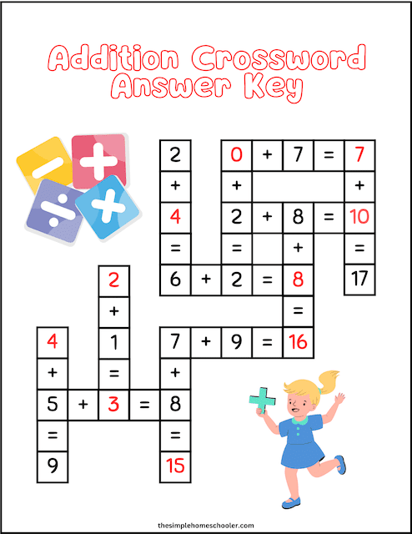

V

SUBJECTIVE (75)
ARITHEMATIC (Marks: 30)
Note: Attempt any eight (8) in all each question carry equal marks.
Attempt any 8 questions. Each question carries equal marks.

Q1) Multiply: (any 3)
(a) 145×36 (b) 569×34 (c) 2.7×2 (d)15.48×4

Q2) Divide: (any 2)
(a) 2.18 ÷ 2 (b) 6078÷4 (c) 71.85 ÷ 5 (d) 1362÷6

Q3) Round each decimal to the nearest whole number.
S.NO | WHOLE NUMBER | NEAREST 1 DECIMAL PLACE | NEAREST 2 DECIMAL PLACES
1 | 9.4 ________ | 45.04 __________ | 16.986 ________
2 | 65.8 ________ | 2.567 __________ | 2.185 _________

Q4) Express each of the fractions as a decimal (any 2)
(a) $\frac{4}{5}$ (b) 5 $\frac{3}{4}$ (c) $\frac{3}{20}$

Q5) Express each of the following as a fraction or a mixed number in its simplest form. Leave each answer in its simplest form (any 2).
(a) 0.25 (b) 5.45 (c) 2.04 (d) 0.8

Q6) Add: Find the sum of each pair of numbers (any 2)
(a) $28.09$ and $3.65$
(b) $5.7$ and $6.24$
(c) $2.63$ and $8.5$
(d) $1.95$ and $3.67$

Q7) Find the difference between each pair of numbers (any 2)
(a) $30$ and $5.84$
(b) $2.09$ and $1.32$
(c) $38.9$ and $3.65$
(d) $0.17$ and $0.04$
Q8) A farmer had 3096 carrots. He packs them equally into 3 boxes. How many carrots are there in each box?

Q9) Subtract:
(a) Subtract 0.08 from 1.23 (b) Subtract 2.19 from 22.08

Q10) 10 o'clock in the afternoon is 1:00 p.m. (This question seems incomplete or asks for a time conversion/comparison.)

GEOMETRY (Marks 15)
Note: Attempt any three (3) questions each question carry equal marks.
STATISTICS (Marks 10)
Note: Attempt any two questions each question carry equal marks.

